Food Standards Australia New Zealand
On-farm food safety practices survey of strawberry growing in Victoria
Joint survey between the Department of Economic Development, Jobs, Transport and Resources (DEDJTR) and Food Standards Australia New Zealand (FSANZ)
May 2016

On-farm food safety practices survey of strawberry growing in Victoria
Contents
Executive summary 2
1. Introduction 6
1.1 Food safety rationale for study 6
1.2 Objectives and assumptions 8
1.2.1 Anticipated outcomes from the survey included: 8
1.2.2 Why survey strawberries? 8
2. Method 9
2.1 Survey design and administration 9
2.1.1 On-farm survey 9
2.1.2 Sampling for E. coli detection 10
2.2 Analysis of on-farm survey data 10
3. Results 11
3.1 Part 1: On-farm survey results 13
3.1.1 Overview 13
3.1.2 Environment 13
3.1.3 Water/fertiliser 13
3.1.4 Quality Assurance 14
3.1.5 Traceability 14
3.1.6 Distribution 14
3.1.7 Harvesting and handling practices 16
3.1.8 Staff facilities 17
3.1.9 Understanding microbiological risks 17
3.2 Part 2: Microbiological survey results 17
4. Discussion 18
5. Conclusions 22
6. Appendices 25
7. References 26

Executive summary
In 2013, Food Standards Australia New Zealand (FSANZ) proposed a primary production and processing standard (PPPS) for horticulture. However, after consultation in February 2014, FSANZ assessed the Proposal and decided to abandon it in favour of a non-regulatory approach. In abandoning the Proposal, FSANZ undertook to further investigate food safety initiatives in horticulture with a view to developing a non-regulatory approach.
Non-regulatory industry-based food safety schemes have been developed for the horticulture sector in Australia and implemented widely. However there are no nationally consistent food safety regulatory requirements on the primary production of horticultural produce. This is unlike the situation in other primary production sectors such as meat, poultry, dairy, eggs and seafood that have standards in the Australia New Zealand Food Standards Code.
For a non-regulatory approach to succeed, growers’ knowledge of microbiological contamination and their ability to manage the risks is important in delivering a safe product to consumers. There is currently little data about the knowledge, attitudes and practices of growers regarding microbiological contamination of horticultural produce for on-farm and processing activities in Australia. An understanding of contemporary practices, skills and food safety knowledge of growers may identify a need for new or updated guidance.
To understand the current grower and on-farm information gaps, the Victorian Department of Economic Development, Jobs, Transport and Resources (DEDJTR) and FSANZ undertook a survey of Victorian strawberry growers in the Yarra Valley during the 2014/15 growing season. The Yarra Valley is where 75% of the States strawberry farms are located. The Victorian strawberry industry was selected for the survey as unprocessed ready-to-eat products, such as strawberries, are considered by food safety professionals as high-risk for food borne illness if they are not grown and handled under systems of good agricultural and hygienic practice. Also DEDJTR has an existing relationship with the industry. The survey was included in the Implementation Subcommittee for Food Regulation (ISFR) coordinated food survey plan (CFSP) and aimed to:
- collect information regarding the on-farm practices and production activities that contribute to the production of safe horticultural produce;
- use the faecal indicator organism E. coli as an indicator of hygienic practices to identify any unmanaged or poorly managed risks as potential targets for guidance; and
- report the survey findings to ISFR.

The key survey findings:
Thirty-three strawberry farms, of the estimated sixty commercial farms in Victoria, participated in the survey. The participating farms comprised a representative sub-set of the industry and included both small and large farms.
The survey methodology used targeted discussion and observational techniques and proved to be an effective way of obtaining information from farmers, particularly those less likely to respond to more rigid, audit style questioning approaches.
The survey methodology provides a model for food regulators to use in similar industries to gain a deeper understanding of the industry structure, food safety knowledge levels and on-farm practices.
No | Key food safety findings
1. | The survey demonstrated that on-farm food safety in the Victorian strawberry industry is generally well managed, regardless of whether growers have a good knowledge of food safety and/or have a recognised quality assurance system.
2. | All farms harvest and pack the strawberries on the same property. However, once fruit leaves the farm, it often travels through a range of distribution routes and purchasing agents. These include supply to wholesale markets; direct to retail; farmers markets and farm gate sales. The complex nature of the distribution routes provides challenges for product traceability, in particular, for the sale of unlabelled second-grade strawberries.
3. | The location of the farms on the hilly topography of the Yarra Valley is useful in preventing crops from being exposed to food safety risks associated with water run off or flooding.
4. | The adoption of practices to reduce costs and improve productivity, such as drip irrigation, have complementary food safety risk management benefits.
5. | Pesticide use has been reduced significantly due to the widespread adoption of Integrated Pest Management (IPM) system by growers.
6. | A satisfactory standard of hygienic food handling was observed during the survey, accompanied by a high level of glove use.
7. | No E.coli was detected in any of the 330 strawberry samples collected and tested. While the test results cannot prove that all strawberries produced in the production system were free from pathogenic microorganisms, it does indicate that production systems are largely working to address food hygiene matters.

The opportunities identified for guidance, improvement and/or further investigation:

No | Category | Opportunity | Potential Food Safety Benefit
1. | Food safety knowledge of growers | Improving the food safety knowledge of growers with particular focus on those without quality assurance/ food safety systems. | Very beneficial:  There is horticulture food safety guidance material available. The 56% of growers with quality assurance/food safety systems in-place have a better understanding of the food safety risks they need to manage. Improving the food safety knowledge of growers is valuable and particular focus on those without quality assurance/food safety systems will assist them similarly.
2. | Farm environment food safety risks | Investigate whether the occasional presence on crops of feral animals, such as ducks, birds, rabbits, foxes and mice, poses a food safety concern. | Low benefit:  There is benefit in understanding this concern better. However, the growers fruit sorting practices during picking and packing helps to mitigate any potential food safety risk from occasional feral animal presence on the crop, through the discarding of any visibly contaminated fruit. Although, microorganisms can be present without being visible.
3a. | Food safety practices | Only use potable water for overhead spray irrigation of crops in the field. | Low benefit:  Drip irrigation systems are now used on almost all farms and overhead water spraying is generally not practiced due to the high cost of water. Overhead water spraying is only used by a few growers during times of extreme weather events to cool crops.  Growers that only have access to untreated dam, creek or bore water, should not undertake overhead spraying or ensure the water is treated to a potable standard (ie water safe for drinking) before applying it to crops.
3b. |  | Seek an alternative method to the use of cloth towels for drying strawberries during packing on rainy days. | Very beneficial (for a very small number of farms):  Packing shed staff at a small number of farms were observed using cloth towels to dry strawberries for quality reasons. This practice has the potential for microorganisms to accumulate on the towels during the day and become a food safety risk. This practice should be discontinued.
4. | Hygienic food handling | Instructions to staff regarding glove use should clearly inform them of the reasons for this hygiene requirement.  The provision of hand sanitisers for food handling staff is useful, however, they are ineffective against viruses such as norovirus. | Low benefit:  A satisfactory standard of food hygiene practices was observed during the survey. Glove use by the food handlers was overall high and hand-sanitisers were available on some farms.  While hand-sanitisers are useful against bacteria they are relatively ineffective against human viruses, such as norovirus, and where possible the use of clean gloves or hand-washing is preferred.  Instructing staff on the reasons for the use of clean gloves will assist with hygienic food handling.
5. | Staff facilities | Investigate the need for additional toilet facilities to be available in the field for workers. | Low benefit:  All farms have toilets. Seven of the 12 large farms had toilets in the field for the convenience of staff.  No E.coli was detected in the strawberry testing.  However, considering the distances required for field staff to access toilets on some farms, it is unclear if conveniently located toilets in the fields is necessary for food hygiene reasons.
6. | Product traceability | Growers to implement food identification labelling for punnets of second-grade strawberries, to meet the food traceability requirements of the Australia New Zealand Food Standards Code. | Very beneficial:  Implementing the food identification labelling requirements of the Australia New Zealand Food Standards Code is useful for product traceability in the unlikely event of a product recall.
7. | Advantages of  food safety systems | Communicate the advantages of certified food safety systems to the significant proportion (44%) of growers that do not currently have a system. | Moderate benefit:  Food safety risks are generally well managed by Victorian growers. However, the benefits of having a quality assurance system provides growers with a greater awareness of the potential food safety risks in their production system. This places a grower in a better position to manage these potential risks.

Introduction
In 2013, Food Standards Australia New Zealand (FSANZ) proposed a primary production and processing standard (PPPS) for horticulture. The aim of the PPPS was to create a regulatory standard to strengthen food safety and traceability throughout the horticulture supply chain. Horticulture is the only primary industry that does not have a regulatory PPPS.
However, after consultation, FSANZ assessed the Proposal and decided to abandon it in favour of a non-regulatory approach. In abandoning the Proposal, FSANZ undertook to further investigate food safety initiatives in horticulture with a view to developing a non-regulatory approach.
In response to this commitment, the Victorian Department of Economic Development, Jobs, Transport and Resources (DEDJTR) and FSANZ undertook a survey of Victorian strawberry growers in the Yarra Valley during the 2014/15 growing season. The survey aimed to establish baseline information about current food safety management practices during growing, harvesting and processing. Strawberries were sampled in parallel with the survey to test for the presence of the faecal indicator bacterium E. coli. Results from the study were intended to:
- Identify areas for further investigation or targeting for guidance for strawberry growers and;
- Inform development of a national non-regulatory approach to food safety for horticulture.

1.1 Food safety rationale for study
In the course of assessing its Proposal for the horticulture PPPS, FSANZ identified key risk factors for contamination of fresh ready-to-eat vegetables (such as leafy greens and herbs) and fruits (such as berries and melons). The risk factors identified were the use of poor quality water for irrigation and/or during initial processing, the use of biological fertilisers or direct faecal deposition in the field.
Growers’ knowledge of microbiological contamination and an ability to manage the risks are important in delivering a safe product to consumers. While some growers understand and manage the risks effectively, other growers may have adopted standard practices without fully understanding that they manage microbial food safety risks. Conversely, others may know of the risks, but their practices are poor.
There is currently little data about the knowledge, attitudes and practices of growers regarding microbiological contamination of horticultural produce for on-farm and processing activities in Australia. This study aimed to clarify some of these questions for the Victorian strawberry industry and serve as a pilot for studies in other industries and jurisdictions.

1.1.1 Regulatory environment
Non-regulatory industry-based food safety schemes have been developed for the horticulture sector in Australia and implemented widely. However there are no nationally consistent food safety regulatory requirements on the primary production of horticultural produce. This is unlike other primary production sectors such as meat, poultry, dairy, eggs and seafood that have standards in the Australia New Zealand Food Standards Code. In addition, there is no standardised or industry agreed traceability for horticulture produce through the supply chain. However, some elements of traceability are provided through food receipt and recall provisions of Standard 3.2.2, along with labelling requirements under Standard 1.2.2.

1.1.2 Industry food safety initiatives
The Horticulture industry has undertaken steps to provide food safety guidance and systems for adoption by businesses in the sector. The majority of fresh produce grown in Australia is produced under industry-based food safety systems. The main food safety systems adopted by horticulture growers include Salad GAP, Freshcare Code of Practice, SQF 1000 Code, Global GAP Integrated Farm Assurance and the domestic retailers quality assurance standards and requirements of Coles Supermarkets Australia Limited and Woolworths (Food Standards Australia New Zealand, 2014).
The Fresh Produce Safety Centre (FPSC) is an industry-led, not-for-profit company established to enhance fresh produce safety across Australia and New Zealand through research, outreach and education (Fresh Produce Safety Centre).
In August 2015, the FPSC published Guidelines for Fresh Produce Safety. The Guidelines are designed to achieve greater consistency in the development, implementation and auditing of fresh produce food safety systems. They are a new resource for growers, packers, wholesalers, retailers, trainers, consultants, auditors, standard owners and regulators, ensuring greater certainty and consistency in the development, implementation and auditing of fresh produce food safety systems.
The immediate benefits to the fresh produce industries in Australia and New Zealand is an up-to-date reference resource that supports the harmonisation of food safety practices and systems.

1.1.3 Information gaps
The Implementation Subcommittee for Food Regulation (ISFR) previously considered a horticulture survey proposal in 2013. The survey proposal was not included on the coordinated food survey plan (CFSP) due to a concern that the survey did not address on-farm causes or sources of contamination. It was considered that assessment of food safety gaps further along the food chain, without consideration of gaps at the source, would limit the effectiveness of control measures implemented by the controlling authorities. ISFR suggested that any future survey proposal should target primary producers’ skills and knowledge regarding provision of safe food.
Although there have been some surveys of fresh horticultural produce in Australia, the majority analysed retail samples for the presence of pathogens, rather than sampling at the farm. Where surveys analysed samples at or close to farm level, low levels of contamination were found. In 2006, the former Department of Primary Industries Victoria sampled lettuce (whole), celery, salad mixes, spring onions and baby spinach before harvest, after harvest and packing and after delivery to retail. E. coli was detected in 15% of samples at harvest with 7 of 360 samples demonstrating levels of greater than 20 cfu/g. An Implementation Sub-committee (ISC) coordinated survey conducted during 2005 to 2007 showed that 24 out of 369 samples were positive (≥ 3 Most Probable Number) for E. coli at farm level. Produce sampled included whole lettuce, seed sprouts, strawberries, parsley and basil. ISC concluded that factors contributing to contamination of horticultural produce would need further investigation during consideration of risk management measures.
This current survey of Victorian strawberry growers meets the objectives of the ISFR Surveillance and Monitoring Working Group and can be considered applied research according to the CFSP Protocol, aimed at enhancing knowledge and addressing information gaps.

1.2 Objectives and assumptions
The aim of the survey was to:
- collect information regarding the on-farm practices and production activities that contribute to the production of safe horticultural produce including gaining an understanding of growers food safety knowledge; and
- by using the faecal indicator organism, E. coli, as an indicator of hygienic practices, identify any unmanaged or poorly managed risks as potential targets for guidance.
Greater understanding of contemporary practices, skills and food safety knowledge of growers may identify a need for new or updated guidance.
Prior to the survey it was unknown how many strawberry growers had quality assurance systems and the adequacy of food safety management in production and processing operations.

Anticipated outcomes from the survey included:
- Clarifying the need for food safety guidance for the horticultural produce sector through identification of risk areas for targeted guidance (new or updated) for growers, including certain events such as heavy rainfall which may have food safety implications.
- Potential for results of the survey to provide input into other horticulture food safety initiatives such as industry reviews of guidelines for horticulture food safety.
- Understanding the growers’ preferred methods of sourcing information to assist with any communication of food safety guidance material.

1.2.2 Why survey strawberries?
The Victorian strawberry industry was selected for a pilot food safety study for a number of reasons including:
- DEDJTR has an existing relationship with the industry, which enabled it to negotiate access to farms and growers;
- The industry is concentrated in a small geographical area in Victoria, which made it feasible to visit a high proportion of growers and transport samples back to the laboratory in timely manner; and
- Unprocessed ready-to-eat products such as strawberries are considered by food safety professionals as a high-risk horticulture product for food borne illness, if they are not grown and handled under systems of good agricultural and hygienic practice.

2. Method

2.1 Survey design and administration
A two-part survey was conducted on 33 Victorian strawberry farms in the Yarra Valley during May 2015. Part 1 was an on-farm survey of practices and environmental conditions. Part 2 was a survey of strawberries collected from each farm for presence and level of generic E. coli as an indicator of hygiene. Generic E.coli is a good indicator of food handling hygiene on food products as they inhabit the human and animal intestine. Therefore the presence of E.coli indicates the potential for faecal contaminants to be on a food product. The limitation of using E.coli is that it does not indicate the presence of human viruses such as norovirus or hepatitis A. The Most Probable Number (MPN) analysis technique was used as it is sensitive; provides a good opportunity for recovery of the organism; and provides an indication of level of contamination through reporting the estimated number of viable organisms present in the sample (Craven et al, 2003).
The number of farms sampled (n=33) was based on the assumption that a 10% prevalence of contamination exists. Sampling this number of farms assumes, with 95% confidence, at least one result would be positive for E. coli.

2.1.1 On-farm survey
An on-farm survey instrument was developed to act as a prompt for questions and observations of on-farm practices (see Appendix 1 for survey instrument). The food safety subject areas where information was collected include:
• Farm demographics
• Quality assurance systems
• Traceability
• Distribution chain
• Farm location
• Presence of animals (domestic and wild)
• Flood water mitigation
• Water sources
• Fertiliser use and storage
• Harvesting – equipment and packing shed practices
• Staff facilities and Hygiene
• Information sources
• Knowledge of food safety risk factors.

The survey was administered by two DEDJTR officers with expertise in food safety and farming systems.
Participants in the survey were recruited by an introductory letter, followed by phone calls and farm visits. The level of participation was aided by the provision of support from the Victorian Strawberry Growers Association.
On completion of the survey, the farms were divided into two groups (small and large) based on size for those farms where farm size was recorded. Small farms had strawberry cropping areas of less than or equal to 6 ha (n=16) and large farms greater than 6 ha (n=14).

2.1.2 Sampling for E. coli detection
Ten 250 g punnets of strawberries were collected post packing from each of the 33 farms surveyed. Each punnet was placed in an individual plastic bag, which was sealed and placed in an esky with ice for storage prior to transport to a commercial laboratory in Melbourne for analysis.
Samples were transported by car to the laboratory at the end of each day’s sampling. Samples were maintained on ice during transport.
Test undertaken: Generic E.coli counts
AS 5013.15-2004 Food microbiology - microbiology - General guidance for the enumeration of presumptive Escherichia coli - Most probable number technique.

2.2 Analysis of on-farm survey data
Microsoft Excel was used to analyse responses to the survey. Due to the design of the survey instrument, qualitative responses were categorised according to a subset of completed surveys. Entry of data from all completed surveys was then coded assigning a ‘1’ or ‘0’ for ‘Yes’ and ‘No’ responses respectively. Where no information was recorded, the cell was left blank. For categories where no data were recorded, n is less than 33.
Where qualitative responses were unable to be transformed into quantitative variables, responses were reported as proportions. Where quantitative transformation of the data was possible and sufficient data existed, some statistical analysis was also conducted.
The survey results were analysed to determine whether farm practices were influenced by farm size. Surveyed farms were divided into two groups (small and large) based on size for those farms where farm size was recorded. Small farms had strawberry cropping areas of less than or equal to 6 ha (n=16) and large farms greater than 6 ha (n=14). No data for farm size were recorded for three of the 33 farms.
Statistical analysis and figures were developed in R version 3.3.2 (R Core Team, 2015). Confidence intervals (95%) of proportions were calculated using the Pearson-Klopper method (Dorai-Raj, 2014). Fisher’s Exact Test for Count Data was used to compare differences in practices between farm size groups.

Results

Industry overview
Today there are around 60 commercial strawberry farms within Victoria, ranging from Portland in the south west to Wodonga in the north east. Strawberries have been commercially grown in the rich fertile soils of Victoria's Yarra Valley since the 1950s. The majority of farms, 75%, are still located within the Yarra Valley, and theses farms produce almost 95% of the States volume of strawberries (Figure 1).

Figure 1: Location of Strawberry Farms in Victoria

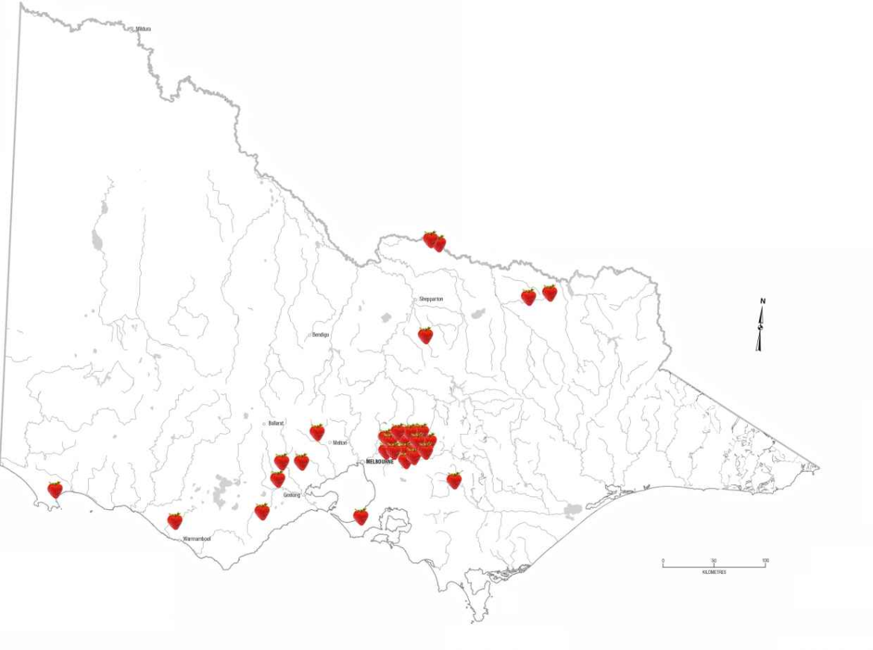
The Victorian strawberry industry supplies fruit to the Australian market for almost nine months of the year beginning in October. The annual production is approximately 25,000 tonnes, with an estimated farm gate value of $180 million (Table 1).

Table 1: Victorian Strawberry Industry Production and Value
Number of farms | Number of plants (millions) | Area (ha) | Production (tonnes) | Average packed yield (punnets per plant) | Industry value - farm gate (million $)
60 | 33 | 230 | 25, 000 | 3.5 | 180
Source: Jason Hingston, Victorian Strawberry Growers Association, 2015

Yarra Valley Growing Conditions
Strawberries grow best when the nights are cool and the days are warm. The Yarra Valley is cool relative to the rest of Australia's strawberry growing regions. Rainfall is dominant in winter and spring, with the summer relatively cool, dry and humid.
The topography of the Yarra Valley varies from gently sloping to rolling undulating countryside and the elevation varies from 50 m – 400 m.

Typical Growing, Picking, Packing and Distribution Practices in Victoria
Most commercial strawberry producers begin preparing their land for the planting of new strawberry crops in late August. The land is fertilised and ploughed, and the soil is mounded into plateau rows and covered with black plastic. When the plastic is laid, drip-tape irrigation is simultaneously placed in the ground. Planting is still done by hand, usually about two weeks after the plastic mulch has been laid. At this time, a tractor is used to mechanically punch holes in the plastic at exact intervals. Workers usually ride or follow behind the tractor and place individual strawberry plants (also called ‘plugs’) into the punched holes. Between 6,000 and 8,000 strawberry plants are planted per hectare (7,000 average). For a large commercial strawberry farm, hundreds of thousands or even millions of strawberry plants will be planted each year. A pump house is used by most commercial growers to water and fertilise the strawberry plants as they grow and produce. The pump house provides the water and nutrients that the strawberry plants need, through the drip irrigation lines.
The Victorian strawberry growers have demonstrated that they are willing to adopt new technologies. They have widely adopted an integrated pest management (IPM) system that reduces the use of chemicals for pest control. IPM is an environmentally sensitive way of managing pests and uses a combination of controls to suppress pests. The controls include using predator bugs, parasites or microbes that are pathogenic to certain insects. Chemical pest controls are only used when needed, and growers select the least toxic pesticides for application to crops. IPM is proving a very successful pest management system compared to regular preventative spraying, and significantly reduces the potential for chemical residues to be present on the fruit.
Strawberries are a very delicate fruit with a very short shelf life of 10 to 12 days from picking. The fruit can be easily damaged by excessive heat and rain during growing. The fruit is picked and packed by hand. Care in handling the fruit during these processes is very important. Any slight bruise or blemish can result in mould growth. One affected strawberry can allow mould growth to quickly spread through a punnet and potentially spoil a larger consignment to market. Therefore, the quality control grading of strawberries during packaging to remove bruised or blemished fruit is a major industry focus. Fruit wastage from the grading process can be very substantial and particularly high during extreme weather events. Growers have reported wastage in excess of 40% in some extreme instances.
The supply chain for strawberries is initially straight forward with harvesting and packing occurring on the same property. However, once the fruit leaves the farm, it often travels through a range of distribution routes, including supply to wholesale markets, direct to retail, farmers markets and farm gate sales.

Part 1: On-farm survey results

3.1.1 Overview
Thirty-three strawberry farms were surveyed during May 2015. Farms were located predominantly within the Yarra Valley region in Victoria.
Seven of the 33 farms grew crops other than strawberries. Most farms (32/33) packed produce on farm. No information about packing was recorded for one farm.
The area under production for strawberries was recorded for 30/33 farms. The range was
1–16 ha with a median of 6 ha.

3.1.2 Environment
Farms were generally located on hilly or sloping terrain. Only one farm was located at the bottom of a valley.
Water sources were visible on most (22/29) farms where information was recorded. Less than half of the surveys (12/30) recorded visibility of livestock on adjacent properties. These were mainly cows (6/12), horses (3/12), sheep (2/12) and chickens (2/12).
Water run-off mitigation was recorded for 26 farms. In most cases this was achieved by growing grass between strawberry beds (24/26). Few farms had underground pipes (2/26) or other drainage systems (2/26) in place. On all farms where livestock was visible on adjacent farms, some form of water run-off mitigation was in place.
Responses to the question, ‘Is there evidence of animals on crops?’, was recorded for 28 surveys. Where a positive response or further information was recorded (18 surveys), ducks/birds (12/18) and rabbits (8/18) were more often noted than evidence of foxes (7/18) and mice (3/18).
No completed survey instrument recorded a notable weather event occurring during the time preceding the survey. Therefore, no inferences were made about impacts of weather events, such as heavy rain, on farming practices.

3.1.3 Water/fertiliser
Responses about water were provided for 26 farms. Water sources were predominantly farm dams (18), mains water supply (13), creek (10) and bore (3). Farms with dams also sourced water from mains water supply (6), creeks (6) and bores (3). Less than half (11/26) of the responses reported that water sources had some form of protection (i.e. fencing). Only five of the 18 dams were fenced. Pump houses provided water to the crops and in all cases were fitted with filtration systems. The filtration systems remove solids to prevent blockages occurring in the drip-tape irrigation.
Farm size did not affect the source of water used. No statistically significant differences between small and large farms (P >> 0.05) were found in the farms using any of the five water sources (mains, creek, dam and bore) reported in the survey.
All farms used fertiliser. However, it was rarely stored on the farm. This may reflect the type of fertiliser used and application practices. This level of detail was not collected. Pelletised chicken manure and commercial blends were the most common fertilisers used (24 and 11 farms, respectively).

3.1.4 Quality Assurance
Forty-four per cent (14/32) of farms did not have a quality assurance (QA) system in place, while 56% (18/32) of farms had one or more QA systems in place. No data about QA systems was recorded for one farm. Twelve farms were recorded as having the Freshcare food safety system, while five had SQF. Freshcare was the most common system in place (65%: 11/17) for farms that packed on farm with a QA system in place.
The effect of farm size was analysed for farms that had information recorded for both farm size (n=30) and QA system (n=32). This resulted in a total sample size for this analysis of 29: 14 large farms and 15 small farms. Farm size was found to be statistically significantly (P = 0.01) related to the presence of a farm QA system. Of all farms where strawberry production area was recorded, approximately half (15/29) had a QA system. When farm size was considered, 26.7% (4/15) of the small farms had QA systems compared with 78.6% (11/14) of large farms (Figure 1(a)).

3.1.5 Traceability
All farms surveyed had some form of traceability system, the majority of which (25/33) included, at a minimum, a consignment note. Two-thirds (22/33) of farms labelled their product. Eight farms kept daily records. One-third (11/33) of farmers could trace fruit back to a particular block.

3.1.6 Distribution
Fruit distribution channels were quite complex with all farms having multiple distribution paths (Figure 2). No information was obtained on the amount of fruit entering each channel.
The distribution channels identified include farms supplying:
- directly to wholesalers,
- through an agent to wholesalers,
- through an agent to retailers,
- directly to retailers, and
- selling fruit at the farm gate and/or markets.
Of the 16 farms that supplied directly to wholesalers, three also sold at farm gate, while two also sold to retailers (either directly or through an agent). Of the four farms that sold directly to retailers, three also sold through an agent to retailers, while one farm also sold direct to wholesale.
Sale of produce to wholesalers, either directly or through an agent, was the predominant supply path for both farms with a QA system (66.6% [12/18]), and those without a QA system (78.6% [11/14]). Distribution to retailers, either directly or through an agent, was higher for farms with a QA system in place [55.5% (10/18)] than for farms without a QA system [28.6% (4/14)]. Three of the four farms that sold fruit at the farm gate or markets did not have a QA system in place.
The percentage of farms using the different distribution pathways was independent of farm size. No statistically significant differences (P >> 0.05) between small and large farms were found for supply direct to the wholesaler, direct to the retail, through an agent to the retailer or farm gate/market sales.

Figure 2: Supply chain for Victorian fresh strawberries

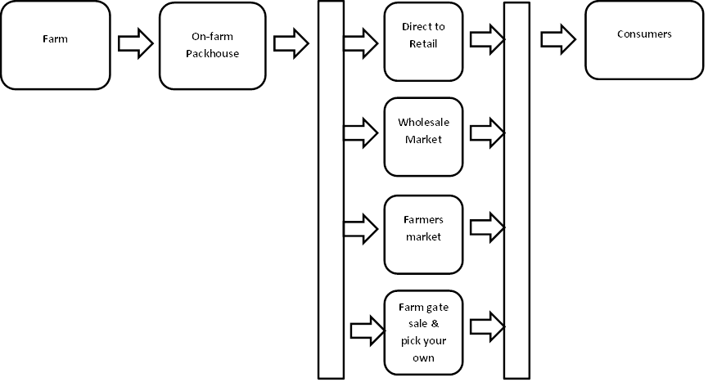

Figure 3: Farm size versus food safety practice

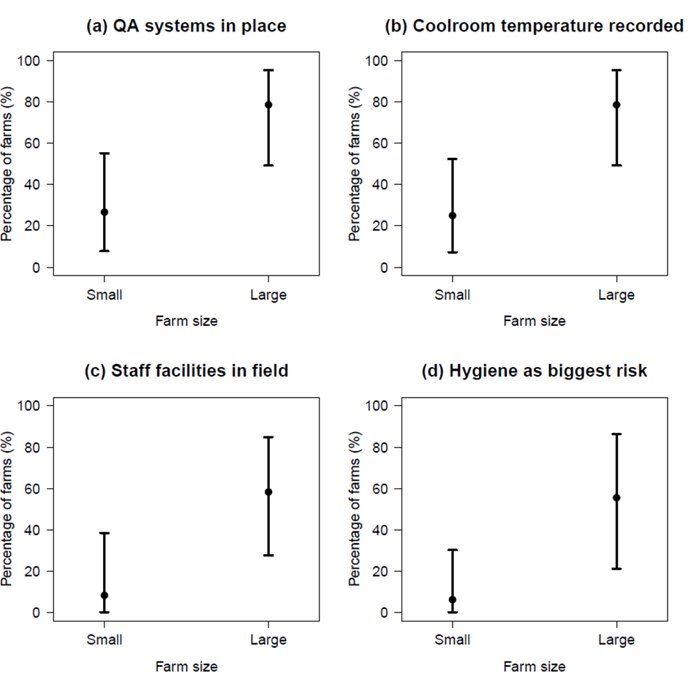
Percentage of farms by strawberry production area (a) QA systems in place, (b) cool room temperature recorded, (c) staff facilities in field and (d) reporting hygiene as biggest risk. Bars represent the 95% confidence intervals calculated by the Pearson-Klopper method (Dorai-Raj 2014). Statistically significant differences (P < 0.05) were found between the farm size groups using Fisher’s Exact Test for Count Data for each of the food safety practices.
Note: A small farm is classified as less than 6 ha and a large farm is greater than 6 ha.

3.1.7 Harvesting and handling practices
Harvesting was observed for 24 of the 33 farms. The observed level of glove useage, for picking and packaging, to reduce the risk of human contamination was high overall. The gloves used are disposable nitrile or latex types, typically used in food manufacturing environments. In the majority of surveys, harvesting equipment was noted as being of clean condition (21/24).
Most farms (30/33) were recorded as having appropriate packing facilities, with a majority of the packing sheds (18/30) able to be sealed. Similar practices were recorded for most farms for packing fruit and cleaning equipment. Three farms (3/30) were recorded as using cloth towels to dry fruit, which were noted as only being replaced at the end of the day.
All farms surveyed had onsite cool rooms. Where further information was recorded (n=29), over half (16/29) were temperature controlled and most were noted as clean and dry (23/29). The remaining six were regarded as being reasonably clean. Significantly more (P = 0.01) large farms (11/14) recorded cool room temperature than small farms (4/16) (Figure 1(b)).

3.1.8 Staff facilities
Toilet facilities were available on all farms and at most packing sheds (26/27). However, the majority of farms did not have additional facilities available in the fields (17/26). Eight farms had facilities available both on the field and at the packing sheds. All farms had soap and towels available for staff hand washing. Hand sanitiser was available in five packing sheds and on four farms in the field.
Information regarding personal hygiene practices was most often (24) displayed on the walls of sheds/toilets. Seven large farms reported regularly instructing staff on hygienic practices.
For the farms that had information about strawberry production area and toilet facilities recorded (n=24), 28.6% (8/24) had toilet facilities available in the fields. Farm size was found to be statistically significantly (P = 0.02) related to the presence of toilet facilities in the fields. One of 12 small farms (8.3%) had facilities in the field, compared with seven of 12 large farms 58.3% (Figure 1(c)).

3.1.9 Understanding microbiological risks
The majority of farmers did not appear to have a good understanding of microbiological food safety risks or the impact that weather conditions may have on this. When asked what the biggest food safety risk was, most farmers answered ‘chemical residues’ (15/24). Similarly, most farmers did not consider that weather, e.g. rain, causing flooding of crops, could affect food safety. It could not be determined whether this response was directly related to their own circumstances and/or location (i.e. location on a slope so no risk of flooding), or a lack of understanding about the impact of rain in general.
Answers to the question, ‘What is the biggest food safety risk?’, split into either chemical residues or (personal) hygiene. A statistically significant difference (P = 0.01) was found between small and large farms in response to this question. Only one of the 16 (6%) small farms identified hygiene as the biggest risk compared with five of nine (55.6%) of large farms (Figure 1(d)).

3.2 Part 2: Microbiological survey results
E. coli was not detected in any of the 330 strawberry samples collected and tested.

Discussion
In abandoning the Proposal for a PPPS for horticulture, FSANZ provided reasons that included:
(a) it was estimated that 70-80% of horticultural produce in Australia is grown under a food safety scheme that contains measures to control identified risk factors;
(b) a deeper understanding of the nature (and type of commodity grown) or number of horticultural businesses that are operating without an industry quality assurance/food safety system should be determined before further regulation in this sector is considered; and
(c) the broader issue of ensuring through-chain traceability for all commodities needs to be addressed. (FSANZ, 2014).
During its assessment of the PPPS proposal, FSANZ identified some key risk factors for contamination of ready-to-eat vegetables. These were the use of poor quality water for irrigation and/or processing, the use of biological fertilisers or direct faecal deposition in the field.
The following discussion will provide a deeper understanding of the Victorian strawberry industries management of key food safety risk factors.

4.1 Key findings:

4.1.1 Quality Assurance/ Food Safety Systems
The survey found that there were no major observable differences in the food safety practices and processes for on-farm harvesting, packaging and storing of strawberries between growers with or without QA systems. Larger farms were more likely to have a QA system in place (78.6%; P = 0.01). This may be linked with market access requirements such as meeting the quality and food safety requirements of major supermarket chains.
The FSANZ estimate of 70-80% of horticulture produce being grown in Australia under a food safety scheme appears to be an overstatement for the Victorian strawberry industry. There was only 56% (18/32) of strawberry farms with one or more QA systems in place. However, the production volume of fruit and not the number of farms is the important factor in understanding exposure to consumers. Of the 30 farms where the area of strawberry planting was reported, the total area was 200.45 hectares. Assuming that planting area for strawberries is directly related to fruit production, then the 16 farms with one or more QA systems represents 67.3% (134.85 ha/200.45 ha) of the total production. This value may be greater if larger farms are more productive per hectare planted. Only 4 of the 15 (26.7%) small farms operated a QA system. Therefore understanding the industry structure, farm productivity and supply chains are important factors to understand before considering any new regulatory approaches or other interventions in horticulture industry sectors.
An additional benefit of QA systems is that businesses are better placed to demonstrate a due diligence defence under section 17E of the Food Act 1984 if a food poisoning event is attributed to their product. A due diligence defence can be demonstrated through the documentation and implementation of a QA system designed to manage food safety hazards including keeping records such as cool room temperature records, traceability documentation and product test results. It may be useful for growers to consider the uptake of an industry food safety system to manage their businesses risk for food safety.
A decade ago, the Victorian Department for Agriculture worked with the industry to introduce Hazard Analysis Critical Control Point (HACCP)-based food safety systems for voluntary adoption. The initiative appears to have had an enduring effect for the industry. Some farmers mentioned that this is how they learned about food safety and how to manage food safety risks, even though they no longer operate a food safety system.

4.1.2 Potential Food Safety Risk Factors
The typical farming, handling and packaging practices observed addressed most food safety risk factors regardless of whether they were specifically implemented to address food safety matters.
Of note there was a complementary food safety benefit in that each strawberry is carefully inspected by staff, at least twice, during picking and packing to remove blemished fruit. This results in the discard of strawberries that are visibly dirty or visibly contaminated with bird or animal faecal matter.
However, microorganism can be present on food without being visible, and the high level of individual fruit handling during picking and packing reinforces the need for hygienic food handling practices to reduce the likelihood of microbiological cross-contamination.
A satisfactory standard of hygienic food handling practices was observed during the survey accompanied by a high level of glove use. The farms with QA systems are required to provide food hygienic practice training. Seven large farms reported regularly instructing staff on hygienic practices. Signage was present in some packing sheds showing good food safety handling practices. Interestingly when queried, some workers stated that they used the gloves to prevent their hands becoming stained ‘black’ by the fruit. In addition, some workers proposed that gloves may have limited value as they do not mitigate cross contamination. Therefore, instructions regarding glove use needs to clearly inform users of the reasons for this requirement. This together with advice on suitable complementary actions such as the use of hand sanitisers, is beneficial for improving hygienic fruit handling. However, it is important to recognise that hand-sanitisers are not a substitute for use of clean gloves or hand-washing. Hand-sanitisers are relatively ineffective against human viruses, such as norovirus, on contaminated hands (Liu et al, 2010).
The risk factors for management that were identified by FSANZ have been addressed regarding poor quality water for irrigation and/or processing, the use of biological fertilisers or direct faecal deposition in the field.
The potential for poor water quality affecting the microbiological safety of strawberries is mitigated as water is not used in the harvesting or packaging of the fruit because it reduces the quality and shelf life of the product. Additionally, the practice of overhead watering of plants in the field has generally ceased by the industry. The only exception is during times of extreme heat where some growers may use overhead watering to reduce the air temperature surrounding crops. The practice is usually limited due to the high cost of water. Drip irrigation systems are now widely used. These systems are installed below the weed mats that cover the raised growing beds so the water, even if potentially contaminated, does not have direct contact with the fruit. If overhead spray irrigation is used, it is recommended that growers ensure that only potable (i.e. water safe for drinking) water is applied to crops.
The likelihood of microbiological contamination of the fruit from fertilisers is very low. This is due to the combination of the growers using approved heat-treated pelletised chicken manure and commercial blends. These are ploughed into the field and left for the recommended number of days prior to planting.
Animals can be a potential source for microbiological contamination. On all farms where livestock was visible on adjacent properties, some form of water run-off mitigation was in place. Eighteen growers reported the occasional presence of feral animals such as ducks, birds, rabbits, foxes and mice. Whilst there was no E.coli detected in the strawberries tested, it is not clear if the presence of feral animals on the crops poses a major food safety concern. This is an area for further investigation. However, there is a complementary food safety benefit through each strawberry being carefully inspected by staff to remove blemished fruit. This results in the discard of strawberries that are visibly dirty or visibly contaminated with bird or animal faecal matter.
Two potential food safety risk factors were observed that may require management. Firstly, the larger farms (58.3%; P = 0.02) were more likely to have toilet facilities in the fields for their harvesting staff. It is unclear if this is a potential food safety concern and whether staff working in the field need to use toilets at times other than when they return to staff facilities during work breaks. However, the provision of toilets in the fields of larger farms is likely to improve convenience for staff and may deliver small productivity gains for growers, by reducing the time required to access facilities. Secondly, three farms were observed using cloth towels to dry fruit prior to packing into punnets on rainy days. The towels were only replaced at the end of the day. It is possible for microorganisms, such as Salmonella and viruses, to accumulate on the towel from any contaminated fruit and be transferred to the next fruit that contacts the towel. This practice is a potential food safety risk and should be discontinued by growers to mitigate the risk.

4.1.3 Microbiological risks and education opportunities
E.coli was not detected in any of the 330 punnets tested. The test results give some level of confidence that the strawberries being grown and packaged in Victoria are produced to a safe food standard for consumers. However, caution is needed when interpreting the results. There are limitations in the sampling plan and the relationship between E.coli and other microbiological risks, such as viruses. The sampling plan was established on the assumption of 10% prevalence of E.coli, and the organism is not a good indicator for the presence of viruses such as Norovirus. The South Australian Research and Development Institute (unpublished) found that, in a 2015 retail survey of berries, samples testing positive for viruses did not have a corresponding positive detection for E.coli.
The majority of farmers do not have a good understanding of microbiological food safety risks. When asked what the biggest food safety risk was, most farmers answered ‘chemical residues’. These answers were surprising given that a food poisoning incident had recently occurred around Australia including Victoria, attributed to imported berries contaminated with Hepatitis A virus. There may be a perception amongst farmers that human viruses are not a potential food safety risk for the production of horticultural produce in Australia, and are only a risk for overseas countries farmers to manage. It is clear that farmers and their staff will benefit from education on the topic of on-farm microbiological food safety risks and good mitigation practices.

4.1.4 Traceability
The growers were found to have traceability from the patch where the strawberries are grown through to packaging in the punnet that, in all instances, occurred on-farm. The growers’ punnets were labelled with the basic food safety traceability information. This includes a business name, address and either a packed-on date or use-by date allowing traceability back to the farm and production batch.
A small number of farms were observed packing lesser quality strawberries, called seconds, that were not labelled with the basic traceability information. The seconds, in all cases, were destined for sale at farmers markets. It is unclear whether sufficient traceability information for these strawberries is passed onto the end consumer at the time of purchase to facilitate product traceability in the event of a food safety investigation. This matter is worth investigating further.

4.1.5 Food safety information sources for farmers
It was observed that farmers with QA systems in place obtained information regarding food safety matters from their food safety auditor. These farmers have a greater knowledge of chemical contamination risks than microbiological risks. Therefore, it may be beneficial to gain a better understanding of the knowledge and attitudes of food safety auditors with regard to microbiological contamination linked to on-farm practices.
There is a wide variety of good quality food safety information and guidance material available from various industry and government sources, such as the Fresh Produce Safety Centre Australia & New Zealand, Horticulture Innovation Australia, FSANZ, Local Government and State and Territory Health and Agriculture Departments. The Victorian Strawberry Growers Association is well placed to be an effective communication channel to engage growers on food safety matters. It is a trusted organisation with a membership comprising over 50% of the Victorian strawberry growing industry.

Conclusions

5.1 Survey methodology

The survey methodology used targeted discussion and observational techniques and proved to be an effective way of obtaining information from farmers, particularly those less likely to respond to more rigid, audit-style questioning approaches. Audit questions can produce standard answers, and can also signal that the objective is simply to achieve a pass or fail.

All growers, once engaged, participated well in discussions and openly provided information regarding their farming practices. Other jurisdictions may wish to adopt this survey approach. The survey instrument is attached as an appendix to the report.

Overall, the survey identified that it is beneficial for food regulators to use similar survey techniques to gain a deeper understanding of an industry’s structure, knowledge levels and on-farm practices.

5.2 On-farm food safety
The survey demonstrated that on-farm food safety in the Victorian strawberry industry is generally well managed, regardless of whether growers are well educated on food safety and/or have a recognised quality assurance system. In part, this is due to adoption of practices to reduce costs and improve productivity, such as drip irrigation, that have complementary food safety risk management benefits.
The Yarra Valley has some useful natural advantages for strawberry production. The hilly topography is useful in preventing crops from being exposed to food safety risks associated with water run off or flooding. All but one of the farms surveyed was on the top or the side of a hill. For all farms where livestock was visible on adjacent farms, some form of water run-off mitigation was in place to reduce the food safety risk.
Crop inputs such as water, fertilisers and chemicals are appropriately managed. For example, water is normally applied to crops by drip irrigation systems that safeguard against any contact with the fruit. Fertilisers used are either heat-treated pelletised chicken manures or commercial blends that reduce the likelihood of microbial contamination of the fruit. There is little need for on-farm storage of fertiliser as products are applied immediately after delivery. Pesticide use has been reduced significantly due to the widespread adoption of IPM by growers.
The observed level of glove use to reduce the risk of human contamination was high overall. When queried, some workers proposed that gloves may have limited value as they do not mitigate cross contamination. The comment highlights the need for growers to instruct their food handling staff to change their gloves when they become visibly unhygienic. As a complementary action, growers may wish to provide hand sanitisers for staff use. Hand sanitiser was available in five packing sheds and on four farms in the field. However, the use of hand sanitisers is not a substitute for use of clean gloves or hand washing. Hand sanitisers, while effective against bacteria, are relatively ineffective against human viruses, such as norovirus, on contaminated hands
The microbiological testing component of the survey found no presence of the faecal indicator organism E. coli, in any of the 330 strawberry samples collected and tested. E.coli testing cannot be used to prove that all strawberries produced are safe to eat, but can provide an indication that the production system is working to address food hygiene matters. The test results, in some degree, complement the overall survey finding; that food hygiene is generally well managed by Victorian strawberry growers.
The survey did highlight some opportunities for guidance, improvement and/or further investigation:
Category | No | Opportunity | Potential Food Safety Benefit
Food Safety Knowledge of Growers | 1. | Improving the food safety knowledge of growers with particular focus on those without quality assurance/food safety systems.  Suggested approach:  The dissemination of basic food safety awareness guidance material is likely to assist growers understand and manage any potential food safety risks, including the risk of human-virus contamination.  The most effective communication channels for dissemination are via:  - food safety auditors, and  - trusted information sources such as the Victorian Strawberry Growers Association.  To facilitate the effectiveness of any communication, it is recommended that food safety auditors actively working in the strawberry industry are engaged to ascertain the level of knowledge regarding microbiological contamination linked to on-farm practices and emerging food safety risks such as norovirus. | Very beneficial:  The 56% of growers with quality assurance/food safety systems in-place have a better understanding of the food safety risks they need to manage. Improving the food safety knowledge of growers is valuable and a particular focus on those without quality assurance/ food safety systems will assist them similarly.
Farm environment food safety risks | 2. | Feral animals on crops:  Investigate whether the occasional presence on crops of feral animals such as ducks, birds, rabbits, foxes and mice; poses a food safety concern. | Low benefit:  This may not be a concern, given that blemished and visibly dirty fruit are discarded by staff during the picking and packing processes. However, it is important to note that microorganisms can be present without being visible.
Food Safety Practices | 3a. | Only use potable water for overhead spray irrigation:  Recommending growers only use potable water (i.e. water safe for drinking) when applying overhead spray irrigation to crops, such as at times of extreme heat. | Low benefit:  Overhead spray irrigation of crops has almost ceased due to high water costs.
 | 3b. | Seek an alternative method to the use of cloth towels for drying strawberries:  For those growers using cloth towels to dry strawberries on rainy days, it is recommended that they seek alternative drying methods, such as single use paper towels, to reduce the potential for microbiological cross contamination of the fruit. | Very beneficial (for a very small number of farms):  Packing shed staff at a small number of farms were observed using cloth towels to dry strawberries for quality reasons. This practice has the potential for microorganisms to accumulate on the towels during the day and become a food safety risk. This practice should be discontinued.
Hygienic food handling | 4. | Glove use instructions and sanitisers for hygienic handling:  Instructions regarding glove use should clearly inform staff of the reasons for this requirement, together with advice on suitable complementary actions to ensure hygienic fruit handling.  The provision of hand sanitisers for use by food handling staff is beneficial against bacteria. However, they are relatively ineffective against human viruses such as norovirus. The use of clean gloves or hand-washing is preferred. | Low benefit:  A satisfactory standard of food hygiene practices was observed during the survey. Glove use by the food handlers was overall high and hand-sanitisers were available on some farms.  No E.coli was detected in strawberry testing.
Staff Facilities | 5. | Toilets in the fields:  Investigating the need for toilets to be available in the field for workers.  Considering the distances required for field staff to access toilets on some farms, it is unclear if installing conveniently located toilets in the fields is necessary for food hygiene reasons. | Low benefit:  All farms have toilets and some have facilities in the fields.  No E.coli was detected in strawberry testing.
Product Traceability | 6. | Implement food identification labelling for second-grade strawberries:  Labelling all punnets of second-grade strawberries, in accordance with Standard 1.2.2 of the Australia New Zealand Food Standards Code, to facilitate traceability of these products. | Very beneficial:  Implementing the food identification labelling is useful for product traceability in the unlikely event of a product recall.
Advantages of Food Safety Systems | 7. | Communicate the advantages of food safety systems:  Implementing a food safety system provides the grower with the benefit of:  - increased understanding of the food safety risks for their businesses management, and  - a due diligence defence should a food poisoning event be attributed to the grower’s product.  It is recommended to provide this information for the consideration of the growers that currently do not have a food safety system in place. | Moderate benefit:  Food safety risks are generally well managed by Victorian growers. However, the benefits of having a greater awareness of the food safety risks, places a grower in a better position to manage these risks.

Appendices
- Survey instrument

References

Department of Health: Food Regulatory System. [Accessed December 2015] Search URL http://www.health.gov.au/internet/main/publishing.nsf/Content/foodsecretariat-system1.htm
Craven, H M., Eyles, M. J., Davey, J.A. (2003): Enteric Indicator Organisms in Foods. Foodborne Microorganisms of Public Health Significance Sixth Edition. Australian Institute of Food Science and Technology.
Dorai-Raj S (2014). binom: Binomial Confidence Intervals For Several Parameterizations. R package version 1.1-1. http://CRAN.R-project.org/package=binom
Fresh Produce Safety Centre Australia and New Zealand: Guidelines for Fresh Produce Safety, August 2015. [Accessed January 2016] Search http://freshproducesafety-anz.com/
Food Standards Australia New Zealand (2014): Abandonment – Proposal P1015 Primary Production & Processing Standard for Horticulture. http://www.foodstandards.gov.au/code/proposals/Documents/P1015-Hort-PPPS.pdf
Food Act 1984, Victorian Legislation. Search http://www.legislation.vic.gov.au/
Liu, P., Yuen, Y., Hsiao, H-M., Jaykus, L-A., Moe, C. (2010): Effectiveness of Liquid Soap and Hand Sanitizer against Norwalk Virus on Contaminated Hands. Applied and Environmental Microbiology 76(2): 394-399.
Personal communication: Jason Hingston, Industry Development Officer, Victorian Strawberry Growers Association [December 2015]
R Core Team (2015). R: A language and environment for statistical computing. R Foundation for Statistical Computing, Vienna, Austria. URL https://www.R-project.org/.
Victorian Strawberry Growers Association (2015): Website source [Accessed December 2015]. URL http://vicstrawberry.com.au/about/

Information on ISFR and the CFSP, refer to the ‘Introduction’ section of the report in the ‘Information gaps’ subsection of the ‘Food safety rationale for the study’. Further information is available in the reference (Department of Health, 2015)

